**Bahria University,**

**Karachi Campus**



**LAB EXPERIMENT NO.**

**05**

**LIST OF TASKS**

|  |  |
| --- | --- |
| TASK NO | OBJECTIVE |
| **01** | **While utilizing the Linux commands studied so far, provide an example (other than the one shown in this Lab) of a combination of several Linux commands in which pipes are used more than once. Also provide a snapshot of the generated output** |
| **02** | **Write C program to print all alphabets from a to z using while loop.(using ASCII)** |
| **03** | **Write a shell script that records the full path of all the files present within a directory into a record.txt file. Along with full path name, the script should also record the number of words, characters and lines within each file** |
| 04 | Write a C program that asks the user to provide an integer input in the *main()* function. The program would call a function *even_odd()* from the *main()* function, where the function *even_odd()* accepts an integer as an argument, determine and display if the passed integer is either even or odd. |

Submitted On:

**6 – 4 – 2023**

(Date: DD/MM/YY)

**LAB TASK 1:** **While utilizing the Linux commands studied so far, provide an example (other than the one shown in this Lab) of a combination of several Linux commands in which pipes are used more than once. Also provide a snapshot of the generated output.**

**SOLUTION:**

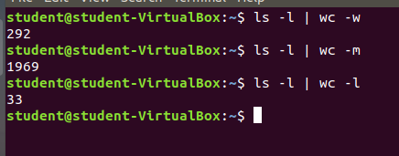

**LAB TASK 2:** **Write C program to print all alphabets from a to z using while loop.(using ASCII)**

**SOLUTION:**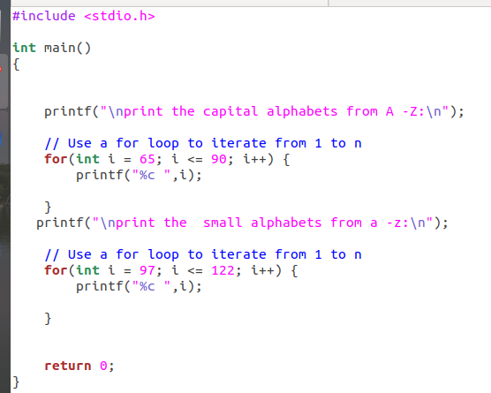

**Output:**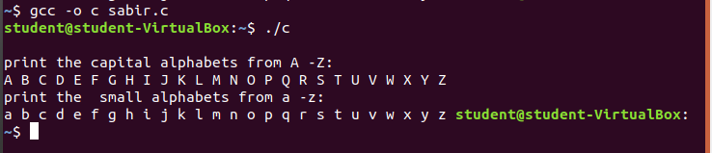

**LAB TASK 3:** **Write a shell script that records the full path of all the files present within a directory into a record.txt file. Along with full path name, the script should also record the number of words, characters and lines within each file**

**Solution:**

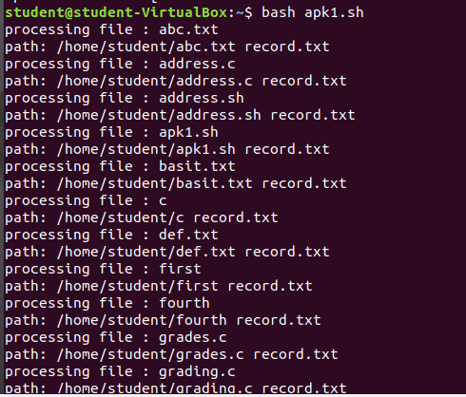**OUTPUT:**

**LAB TASK 4:** **Write a C program that asks the user to provide an integer input in the *main()* function. The program would call a function *even_odd()* from the *main()* function, where the function *even_odd()* accepts an integer as an argument, determine and display if the passed integer is either even or odd.**

**Solution:**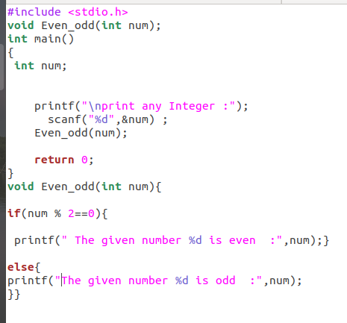

**OUTPUT:**

